**Udacity Self Driving Car Engineer**

**Project 1 – Finding Lane Lines on the Road**

**Writeup**

The goals of this project are the following –

1. Make a pipeline that finds lane lines on the road
2. Reflect on your work in a written report

**Reflection**

1. **Description of Pipeline**

The original image is first converted into grayscale.

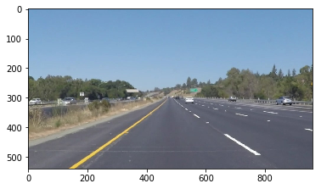 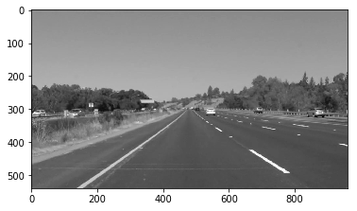

The grayscale image is then passed through Canny to output the edges. The edges are then masked over a region of interest. Hough transform as taught in the lesson then produces lines.

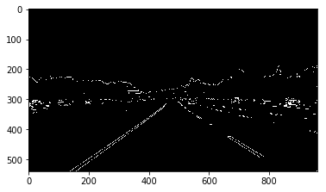 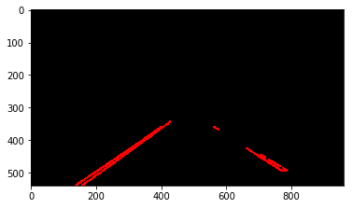

The draw_lines function is modified to calculate the slope and intercept of the hough lines and average these. Once averaged, extrapolated line is drawn from the bottom edge of the image with average slope and average intercept.

Finally, these extrapolated lane lines are overlaid on the original image to produce the result image.

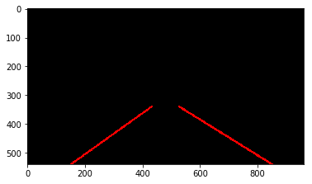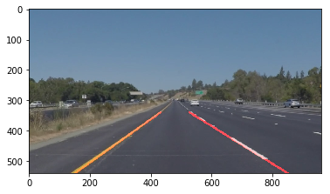

Once the pipeline is tested on a variety of images, it is then copy pasted into the Process Image function. Video files provided in the project are then tried out with the pipeline.

The